**Memo**

**Washington State University**

**To:** AdventureWorks company

**From:** Nam Jun Lee

**Subject:** TSQL #4

**Date:** April 7, 2023

**Statement**

Dataset: AdventureWorksDW2019

Problem 1:

1. Identify products sold on the web retail channel, but not yet sold on the physical stores in Germany.
2. Analyzing the data by city level, identify which products sold in Germany are sold on the internet but not in a physical store in that city.

Problem 2:

Produce a list of the TOP 10 products (that are currently not) sold in physical stores, but due to their popularity (high # of units sold in Germany) that should be sold in physical retail stores in Germany.

Problem 3:

Produces totals for bike sales by and then house addition subqueries to bring in data from the web channel and retail channel. Turn these results into a subquery adding a totals column for each row. And add more functionality such as formatting the data from units to percentages.

**Problem 1**

**Products sold on the web retail channel, but not yet sold on the physical stores in Germany**

The above list shows products sold on web retail channels but not yet sold in physical stores in Germany. Through this list, a total of 73 products are not being sold in German physical stores. Looking at the first five rows of the list, it is judged that these five products are good to increase the number of foot track picks for physical stores, given that "Road Tire Tube," "Mountain Tire Tube," "Mountain Bottle Cage," "Touring Tire Cage," and "Road Bottle Cage" are sold 18005, 12220, 12155, 12025 and 11440 respectively.

**Products sold in Germany are sold on the internet, but not in a physical store in that city**

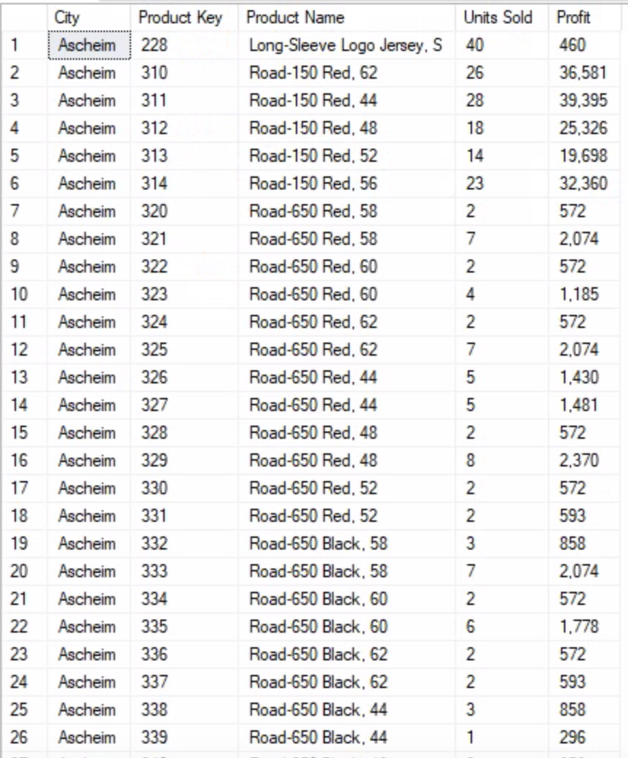

The above list shows only the first page of the results. The full list includes 2,774 products for each of Germany's 38 cities. So, summary of the list, it can see that "Long-Sleeve Logo Jersey, S", "Road-150 Red, 62", "Road-150 Red, 44", "Road-150 Red, 48" , "Road-150 Red, 52" and "Road-150 Red, 56" are very popular products in the city of Ascheim. Also, check the profit, it can see that "Road-150 Red, 62", "Road-150 Red, 44", "Road-150 Red, 48" , "Road-150 Red, 52" , "Road-150 Red, 56" can profit a lot. Therefore, it is judged that selling the top 6 products on the list is good for management to increase foot traffic to physical stores in the city of Ascheim.

**Problem 2**

**TOP 10 products sold in physical stores in entire countries**

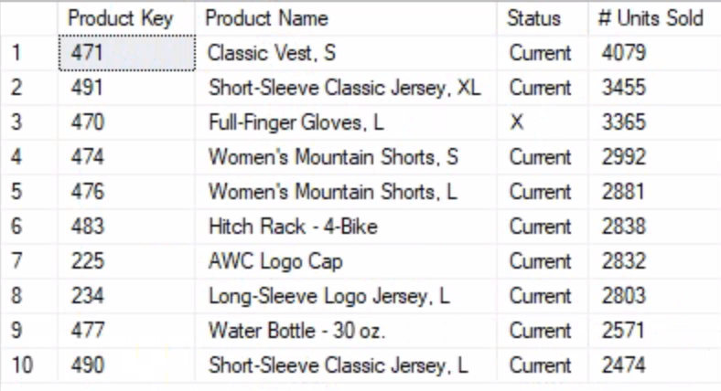

The list on the left shows the top 10 products sold the most in physical stores in all countries. Except for one product (Full-Finger Gloves, L), sales are currently in progress at the store.

**TOP 10 products sold in physical retail stores in Germany**

The list on the left shows the top 10 products sold the most in physical stores in Germany. All products are currently on sale.

Among the products sold well in all countries, "Classic Vest, S", "Short-Sleeve Classic Jersey, XL", "Hitch Rack - 4-Bike", and "Short-Sleeve Classic Jersey, L" are also sold a lot in Germany.

**Top 10 best-selling products in the entire country that are also selling in Germany**

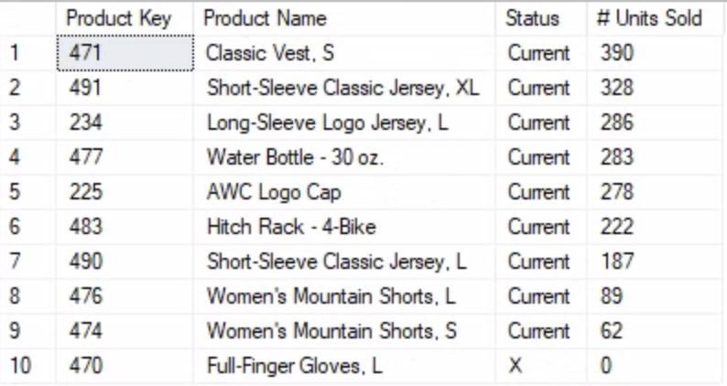

The list on the left shows whether the top 10 best-selling products in all countries are being sold in real stores in Germany. This shows that nine of the top 10 best-selling products in all countries are currently sold in physical stores in Germany, and that "Full-Finger gloves, L" products are still not sold in Germany. As a result, it is believed that selling "Full-Finger Gloves, L" products to real German stores will bring more profits to store management.

**Problem 3**

To solve this problem, a total of four subqueries were used, and each subquery will be described.

**Level 1 Subquery**

The first subquery above shows only the results of the first page of the list. The total list consists of 125 items of bike, which calculated the total retail channel sales, total web channel sales, total units sold in the retail channel, and total units sold in the web channel.

**Level 2 Subquery**

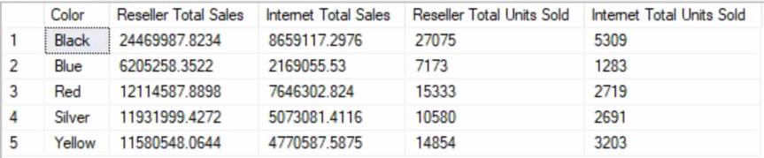

The second subquery above calculates each total retail channel sales, total web channel sales, total retail channel units sold, and total web channel sales units sold by color from the first subquery.

**Level 3 Subquery**

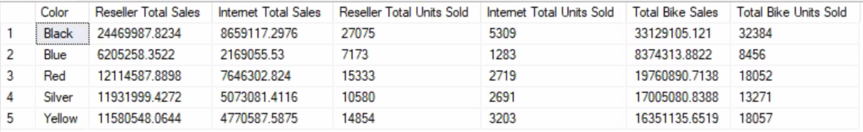

The third subquery above calculates total bike sales by adding each total retail channel sales and total web channel sales and calculates total bike units sold by adding each total retail units sold and total web channel units from the second subquery.

**Top Level Subquery**

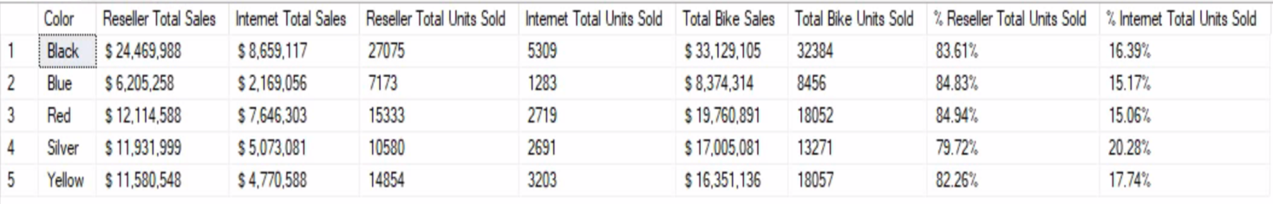

The top-level subquery contains all the results obtained from the previous subquery. These results also included the proportion of retail channel and web channel by total bike units sold.

Therefore, the group with the black bike color has significantly higher sales at $33,129,105 than the other four bike color groups. On the other hand, the group with a blue bike color has significantly lower sales at $8,374,314, compared to the other four bike color groups.

Rank for total bike sales by color is

1. Black
2. Red
3. Silver
4. Yellow
5. Blue

In addition, the above results confirm that sales at the retail channel of all color-specific bike groups are relatively higher than that of the web channel. And the ratio of retail and web channels to total bike units sold shows that average units sold of all color-specific bike groups for a very large proportion of more than 80% in the retail channel and a very low proportion of less than 20% in the web channel.

**Appendix**

**Problem1**

USE [AdventureWorksDW2019];

-- Identify which products sold in Germany are sold on the internet but not in a physical store

SELECT DISTINCT(i.[ProductKey]) as [Product Key]

,[EnglishProductName] as [Product Name]

, SUM([OrderQuantity]) as [# Unit Sold]

FROM [dbo].[FactInternetSales] as i

INNER JOIN [dbo].[DimProduct] as p ON p.[ProductKey] = i.[ProductKey]

INNER JOIN [dbo].[DimGeography] as geo ON geo.[SalesTerritoryKey]= i.[SalesTerritoryKey]

WHERE [EnglishCountryRegionName] = 'Germany'

AND i.[ProductKey] NOT IN

(

SELECT DISTINCT(s.[ProductKey])

FROM [dbo].[FactResellerSales] as s

INNER JOIN [dbo].[DimReseller] as rs ON rs.ResellerKey = s.ResellerKey

INNER JOIN [dbo].[DimGeography] as g ON g.[GeographyKey] = rs.[GeographyKey]

WHERE g.[EnglishCountryRegionName] = geo.[EnglishCountryRegionName]

)

GROUP BY i.[ProductKey], [EnglishProductName]

ORDER BY SUM([OrderQuantity]) DESC

-- Analyzing the data by city level, identify which products sold in Germany are sold on the internet but not in a physical store in that city

SELECT [City],i.[ProductKey] as [Product Key]

,[EnglishProductName] as [Product Name]

, ISNULL(SUM([OrderQuantity]),0) as [Units Sold]

, FORMAT(SUM([UnitPrice] - [TotalProductCost]), 'N0') as [Profit]

FROM [dbo].[FactInternetSales] as i

INNER JOIN [dbo].[DimProduct] as p ON p.[ProductKey] = i.[ProductKey]

INNER JOIN [dbo].[DimGeography] as geo ON geo.[SalesTerritoryKey]= i.[SalesTerritoryKey]

WHERE [EnglishCountryRegionName] = 'Germany'

AND i.[ProductKey] NOT IN

(

SELECT DISTINCT(s.[ProductKey])

FROM [dbo].[FactResellerSales] as s

INNER JOIN [dbo].[DimReseller] as rs ON rs.ResellerKey = s.ResellerKey

INNER JOIN [dbo].[DimGeography] as g ON g.[GeographyKey] = rs.[GeographyKey]

WHERE g.[EnglishCountryRegionName] = geo.[EnglishCountryRegionName]

)

GROUP BY [City],i.[ProductKey],[EnglishProductName]

ORDER BY [City]

**Problem2**

USE [AdventureWorksDW2019];

-- List of the TOP 10 products (Current or Current not) sold in physical stores in all countries

SELECT Top(10) p.[ProductKey] as [Product Key]

,[EnglishProductName] as [Product Name]

, ISNULL([Status], 'X') as [Status]

, ISNULL((SELECT SUM([OrderQuantity]) FROM [dbo].[FactResellerSales] as rs

INNER JOIN [dbo].[DimReseller] as dr ON rs.[ResellerKey] = dr.[ResellerKey]

INNER JOIN [dbo].[DimGeography] as geo ON geo.[GeographyKey] = dr.[GeographyKey]

WHERE rs.ProductKey = p.ProductKey

AND [EnglishCountryRegionName]

IN ('Australia','Canada', 'France', 'Germany', 'United Kingdom',

'United States')), '') as [# Units Sold]

FROM [dbo].[DimProduct] as p

ORDER BY [# Units Sold] DESC

-- List of the TOP 10 products (Current or Current not) sold in physical retail stores in Germany

SELECT TOP(10) p.[ProductKey] as [Product Key]

,[EnglishProductName] as [Product Name]

, ISNULL([Status], 'X') as [Status]

, ISNULL((SELECT SUM([OrderQuantity])

FROM [dbo].[FactResellerSales] as rs

INNER JOIN [dbo].[DimReseller] as r

ON rs.[ResellerKey] = r.[ResellerKey]

INNER JOIN [dbo].[DimGeography] as g

ON g.[GeographyKey] = r.[GeographyKey]

WHERE rs.ProductKey = p.ProductKey

AND [EnglishCountryRegionName] = 'Germany'), '') as [# Units Sold]

FROM [dbo].[DimProduct] as p

ORDER BY [# Units Sold] DESC

-- Check the top 10 best-selling products in the entire country that are also selling in Germany

SELECT p.[ProductKey] as [Product Key]

,[EnglishProductName] as [Product Name]

, ISNULL([Status], 'X') as [Status]

, ISNULL((SELECT SUM([OrderQuantity])

FROM [dbo].[FactResellerSales] as rs

INNER JOIN [dbo].[DimReseller] as r

ON rs.[ResellerKey] = r.[ResellerKey]

INNER JOIN [dbo].[DimGeography] as g

ON g.[GeographyKey] = r.[GeographyKey]

WHERE rs.ProductKey = p.ProductKey

AND [EnglishCountryRegionName] = 'Germany'), '') as [# Units Sold]

FROM [dbo].[DimProduct] as p

WHERE p.[ProductKey] IN (471, 491, 470, 474, 476, 483, 225, 234, 477, 490)

ORDER BY [# Units Sold] DESC

**Problem 3**

USE [AdventureWorksDW2019];

-- Top level Subquery

-- Change data for better viewing and add units to percentages (% of total)

SELECT Color, CONCAT('$ ',FORMAT([Reseller Total Sales],'N0')) as [Reseller Total Sales]

, CONCAT('$ ',FORMAT([Internet Total Sales], 'N0')) as [Internet Total Sales]

, [Reseller Total Units Sold], [Internet Total Units Sold]

, CONCAT('$ ',FORMAT([Total Bike Sales], 'N0')) as [Total Bike Sales], [Total Bike Units Sold]

, FORMAT(CAST([Reseller Total Units Sold] as decimal)/CAST([Total Bike Units Sold] as decimal),'p2') as [% Reseller Total Units Sold]

, FORMAT(CAST([Internet Total Units Sold] as decimal)/CAST([Total Bike Units Sold] as decimal),'p2') as [% Internet Total Units Sold]

FROM

(

-- Level 3 Subquery

-- total bike sales and total units sold

SELECT *

, ([Reseller Total Sales] + [Internet Total Sales]) as [Total Bike Sales]

, ([Reseller Total Units Sold] + [Internet Total Units Sold]) as [Total Bike Units Sold]

FROM

(

-- Level 2 Subquery

-- bike sales and units sold by color

SELECT [Color]

,SUM([Reseller Sales]) as [Reseller Total Sales]

, SUM([Internet Sales]) as [Internet Total Sales]

, SUM([Reseller Units Sold]) as [Reseller Total Units Sold]

, SUM([Internet Units Sold]) as [Internet Total Units Sold]

FROM

(

-- Level 1 Subquery

-- all bike sales and units sold

SELECT d.[Color], d.[EnglishProductName]

, (SELECT ISNULL(SUM([SalesAmount]),0)

FROM [dbo].[FactResellerSales] as s

WHERE s.ProductKey = d.ProductKey

) as [Reseller Sales]

, (SELECT ISNULL(SUM([SalesAmount]),0)

FROM [dbo].[FactInternetSales] as i

WHERE i.ProductKey = d.ProductKey

) as [Internet Sales]

, (SELECT ISNULL(SUM([OrderQuantity]),0)

FROM [dbo].[FactResellerSales] as s

WHERE s.ProductKey = d.ProductKey

) as [Reseller Units Sold]

, (SELECT ISNULL(SUM([OrderQuantity]),0)

FROM [dbo].[FactInternetSales] as i

WHERE i.ProductKey = d.ProductKey

) as [Internet Units Sold]

FROM [dbo].[DimProduct] as d

INNER JOIN [dbo].[DimProductSubCategory] as ds ON ds.[ProductSubcategoryKey] = d.[ProductSubcategoryKey]

INNER JOIN [dbo].[DimProductCategory] as dc ON dc.ProductCategoryKey = ds.ProductCategoryKey

WHERE [Color] <> 'NA'

AND [EnglishProductCategoryName] = 'Bikes'

) sub1

GROUP BY Color

) sub2

) sub3